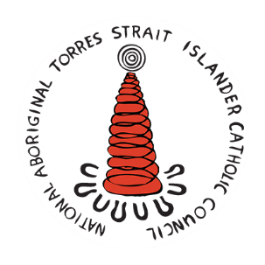
2021 NATSICC Assembly Artwork Competition
Holy Spirit in this Land

Student Submission Form

Name: ________________________________________
School: _______________________________________
Class: _________________________________________
Teacher Contact email: _______________________________________
Do you identify as:
Aboriginal and/or Torres Strait Islander Yes No
Please describe the thought behind your artwork and how it relates to the theme – Holy Spirit in this land
______________________________________________________________________________________________________________________________________________________________________________________________________________________________________________________________________________________________________________________________________________________________________________________________________________________________________________________________________________________________________________________________________________________________________________
Hardcopy submissions can be sent to:
NATSICC Logo Competition – 80c Payneham Rd. Stepney SA 5069

Electronic submissions (accepted in gif, pdf or png (preferred) format)
Please send entries to assembly@natsicc.org.au
Please contact assembly@natsicc.org.au or phone 08 8363 2963 should you have any questions.

